**AOP Extrnal Jar Details:**

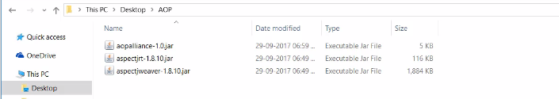

**Aspect Annotations**

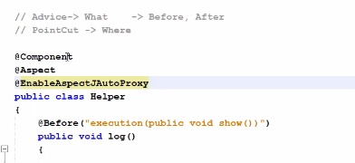

[**http://www.mkyong.com/spring3/spring-aop-aspectj-in-xml-configuration-example/**](http://www.mkyong.com/spring3/spring-aop-aspectj-in-xml-configuration-example/)

[**https://www.mkyong.com/spring3/spring-aop-aspectj-annotation-example/**](https://www.mkyong.com/spring3/spring-aop-aspectj-annotation-example/)